DAILY HABIT TRACKER

UI/UX Design Fundamentals - Christ University

**Submitted By:**

**Team Members:-**

**Full Name & Roll Number:**

Devika T.R & 2462064

Ashitha Vinod K & 2462048

Florentina Francis & 2462070

**College Email id:**

[devika.tr@btech.christuniversity.in](mailto:devika.tr@btech.christuniversity.in)

[ashitha.vinod@btech.christuniversity.in](mailto:ashitha.vinod@btech.christuniversity.in)

[florentina.francis@btech.christuniversity.in](mailto:florentina.francis@btech.christuniversity.in)

**Instructor Name:**

Ms. Nagaveena

**Index:**

* **Abstract**
* **Objectives**
* **Scope of the Project**
* **Tools & Technologies Used**
* **HTML Structure Overview**
* **CSS Styling Strategy**
* **Key Features**
* **Challenges Faced & Solutions**
* **Outcome**
* **Future Enhancements**
* **Sample Code**
* **Screenshots of Final Output**
* **Conclusion**
* **References**

**1.Abstract:**

The *Daily Habit Tracker* is a simple yet effective web-based tool that allows users to record, monitor, and maintain their daily habits. With features like progress visualization, streak calculation, and reset functionality, it helps users stay consistent with their routines.

**2.Objectives:**

• To create an interactive habit-tracking tool.

• To allow users to add, track, and reset habits dynamically.

• To provide a weekly progress view with visual feedback.

• To encourage users in building consistency through streaks.

**3. Scope of the Project:**

• Tracks daily habits for a week.

• Provides progress bars and streak counts.

• Lightweight, browser-based (no backend required).

• Can be extended for long-term tracking with minimal modifications

**4. Tools & Technologies Used:**

• **HTML5** → Structure of the webpage.

• **CSS3** → Styling and layout (responsive, modern design).

• **JavaScript (ES6)** → Logic for habit tracking, progress updates, and dynamic rendering.

**5. HTML Structure Overview:**

• **Container** → Main wrapper (.container).

• **Form Section** → Input field & buttons (#habit-input, #add-habit, #reset-tracker).

• **Table Section** → Displays habit name, progress bar, streak, and checkboxes for 7 days.

**6. CSS Styling Strategy:**

• Clean, minimal design with a light background.

• Rounded corners & shadow effects for modern look.

• Color-coded buttons (green = add, red = reset).

• Progress bar styled with green fill against a gray background.

**7. Key Features:**

• **Add Habit** → Users can add new habits instantly.

• **Track Progress** → Visual progress bar updates dynamically.

• **Streak Calculation** → Longest consecutive streaks calculated.

• **Checkbox-based Tracking** → Easy daily habit marking.

• **Reset Option** → Clears all habits instantly.

**8. Challenges Faced & Solutions:**

1. **Dynamic Rendering of Habits**
   * *Challenge*: Updating habits when checkboxes are toggled.
   * *Solution*: Implemented renderHabits() function to re-render table after every change.
2. **Streak Calculation**
   * *Challenge*: Tracking longest streaks instead of just current streak.
   * *Solution*: Wrote a loop in calculateStreak() that resets when unchecked and stores the maximum.
3. **Progress Bar Calculation**
   * *Challenge*: Visual representation of weekly progress.
   * *Solution*: Calculated checked days percentage and updated inline CSS dynamically.

**9. Outcome:**

• Fully functional web app for habit tracking.

• Provides both numerical (streaks) and visual (progress bar) feedback.

• Clean UI and responsive design.

**10. Future Enhancements**:

• Persistent storage using **LocalStorage** or databases.

• Monthly and yearly tracking views.

• Notifications & reminders.

• Graphs/analytics for progress trends.

• Dark mode support.

**11.Sample Code:**

**This is a sample code not the actual code:-**

<!DOCTYPE html>

<html lang="en">

<head>

<meta charset="UTF-8">

<meta name="viewport" content="width=device-width, initial-scale=1.0">

<title>Daily Habit Tracker</title>

<link rel="stylesheet" href="style.css">

</head>

<body>

<div class="container">

<h1>Daily Habit Tracker</h1>

<!-- Add Habit Form -->

<div class="habit-form">

<input type="text" id="habit-input" placeholder="Enter a habit">

<button id="add-habit">Add Habit</button>

<button id="reset-tracker">Reset All</button>

</div>

<!-- Habit Tracker Table -->

<table id="habit-table">

<thead>

<tr>

<th>Habit</th>

<th>Progress</th>

<th>Streak</th>

<th colspan="7">This Week</th>

</tr>

</thead>

<tbody>

<!-- Habits will appear here dynamically -->

</tbody>

</table>

</div>

<script src="script.js"></script>

</body>

</html>

**12.Screenshots of Final Output**

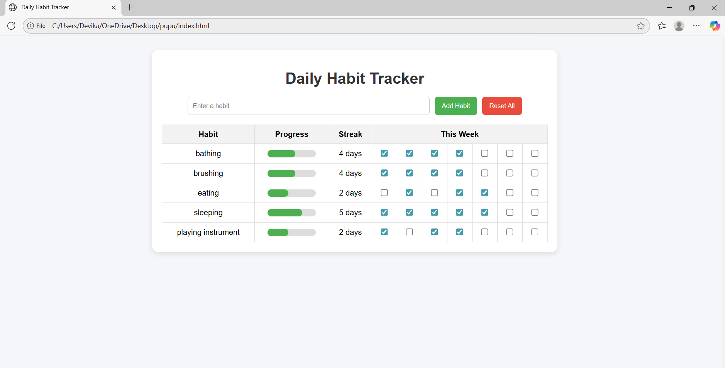

**13. Conclusion:**

The *Daily Habit Tracker* provides a simple yet powerful way for users to stay consistent with their daily routines. Its modular design ensures easy scalability for future improvements while keeping the interface user-friendly and efficient.

**14. References:**

**L&T LMS:**

https://learn.lntedutech.com/Landing/MyCourse

**W3Schools:**

https://www.w3schools.com